ESTATES DIRECTORATE
CAMPUS DEVELOPMENT: MAIN SITE MASTERPLAN: THE WEEK AHEAD, 14 December 2015
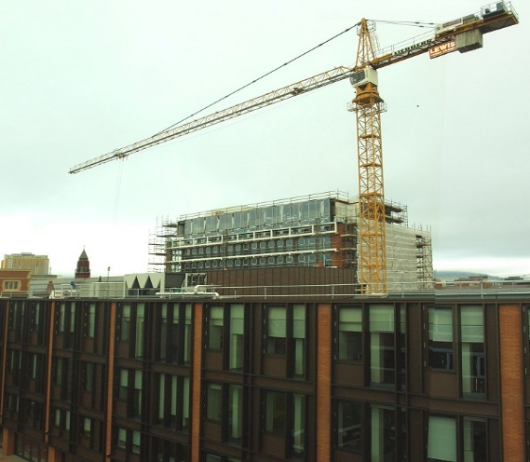
See below for detailed information on what’s happening on 14 December on the Main Site Tower and PFC (School of Law and Social Hub) and Maths and Physics Teaching Centre projects.
These projects are part of an investment of £350m in buildings and facilities over the next ten years to support world-class research and education – for more information click here. The Estates Directorate will continue to do everything possible to manage the impact of works and we hope that they do not cause you too much inconvenience. If you have any comments regarding noise, please contact us on ext.1033 or email estates@qub.ac.uk.
Description of Works | Possible Impact
Main Site Tower/PFC (Completion July 2016)
Minor demolition works in the region of the Main Site Tower to facilitate ongoing services installations. | General site traffic noise, together with noise and vibration from manoeuvring machines, pneumatic tools and hammers.  Footpath on south side of University Square closed, but cycle lane still operational.  Pedestrian diversions in place on University Square - approach with care!  Temporary loss of 3 car parking spaces adjacent to Lanyon North.  Please note that access to the Graduate School via the Naylor Arch has been closed and will re-open again on 1 February 2016. Please see the attached plan for alternative pedestrian routes.
Installation of cladding and associated secondary steelwork
Adjusting of scaffolding and hoarding to facilitate ongoing works around the Main Site Tower.

Brick and stonework repair to lightwell, School of Music building are complete. Minor defects being addressed. | Access to the School of Music will be maintained at all times, but please follow designated, signposted routes.
Addressing minor defects to the completed PFC works. | No impact anticipated.
School of Mathematics and Physics Teaching Centre (Completion Spring 2016)
Contractor operations in and around the former Postgraduate Student Centre. | General site traffic noise and minor noise.  Some disruption to pedestrian routes; alternatives are shown on the attached plan.
Contractor deliveries to site before 8am | Site access is being manned by Contractor’s staff.
General internal building works | Some noise from pneumatic tools and hammers.
Installation of Mechanical and Electrical systems

